FootFusion

Use-case-Realization Specification: Manage Shipping Process

Version 1.0

Revision History
Date | Version | Description | Author
26/11/2024 | 1.0 | Final Version | Vu Thi Anh Thu

Table of Contents
1. Introduction 2
1.1 Purpose 2
1.2 Scope 2
1.3 Definitions, Acronyms, and Abbreviations 2
1.4 References 2
1.5 Overview 2
2. Flow of Events—Design 2
3. Derived Requirements 2

Use-case-Realization Specification: Manage Shipping Process

Introduction

Purpose
The purpose of this specification is to define how the Manage Shipping Process use case is realized during the analysis phase. It outlines the interactions between the Shop Owner (seller) and the system, identifies key system components (e.g., user interface, database, third-party APIs), and models the objects and sequences necessary to implement the shipping functionality. This specification aims to provide a detailed understanding of the technical architecture, data flow, and system components involved in managing the shipping process for buyer orders.

Scope
The scope of this Use-Case Realization Specification is to define the analysis and realization of the Manage Shipping Process use case within the system. This specification is directly associated with the Manage Shipping Process use case model, which enables Shop Owners to efficiently handle the shipping of buyer orders. This includes reviewing order details, selecting shipping options. The specification covers the interaction between the Shop Owner and the system.

Definitions, Acronyms, and Abbreviations
None.

References
None.

Overview
The following sections of the document detail the design and derived requirements for the implementation of the use case. The Flow of Events - Design section focuses on the design aspects of the use case, providing a textual explanation that outlines the steps and interactions involved. It also includes a sequence diagram that visually represents the chronological order of interactions between the actors and system components. Additionally, a class diagram is presented, illustrating the relevant classes and their relationships within the context of the use case. Together, these elements offer a thorough understanding of the design choices and system behavior associated with the use case.
Furthermore, the document outlines the derived requirements that must be considered during the implementation phase. These requirements define the functionalities, constraints, and system behaviors necessary to fulfill the use case's objectives. They serve as essential guidelines for developers and stakeholders to ensure that the system meets the expected standards and operates as intended.

Flow of Events—Design
The Seller initiates the checkout process by clicking on the "Checkout" section from the homepage of the application. This action signals the system to transition to the next phase of the shopping experience. Once the Seller clicks on the checkout section, the HomepageUI updates the user interface to reflect the checkout screen, displaying options and necessary information for the Seller to proceed with the checkout process.
Next, the Seller continues the process by clicking the "Continue Checkout" button, which triggers the CheckoutController to move to the next screen.
After that, the Seller selects options related to the checkout: delivery methods, gift wrapping preferences and then CheckoutOrganizerController takes shippingID. These selections are integral to completing the order, and the CheckoutEntity is responsible for handling supporting functions, such as saving any changes made during the checkout process.

sequence diagram
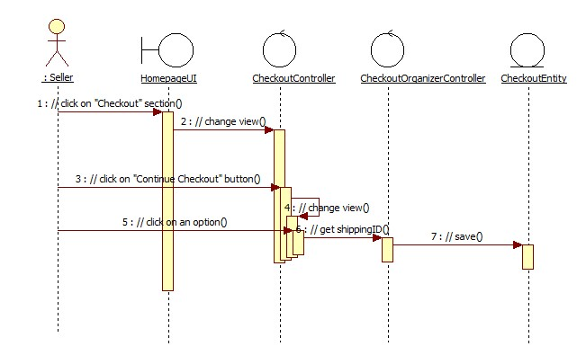

class diagram
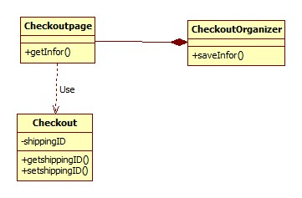

Derived Requirements
- The shipping options for each order must be presented in an intuitive way, allowing the Shop Owner to select the desired shipping method.

